|  |
| --- |
| Requirement driven testing |
| Test Plan for |
| Project name |
|  |
| **Requirement Driven Testing** |
| **[Pick the date]** |

|  |
| --- |
| [Type the abstract of the document here. The abstract is typically a short summary of the contents of the document. Type the abstract of the document here. The abstract is typically a short summary of the contents of the document.] |

# Approval

|  |  |  |  |
| --- | --- | --- | --- |
| AUTHOR | | | |
| <name> | <position> |  | |
| APPROVED BY | | | |
| <name> | <position> |  |  |
| ACKNOWLEDGMENT | | | |
| <enter text> | | | |

# Related Documents

|  |  |
| --- | --- |
| **Ref #** | **Document Name** |
| 01 | High level system architecture |
| 02 | Project brief |
| 03 | Infrastructure design.. etc |

Glossary

|  |  |
| --- | --- |
| Term | Definition |
| Bug | See Defect |
| Defect | Software function does not work as per specification |
| Defect Owner | The person who created the defect |
| Issue | Software function does not work as expected or is not specified |
| RDT | Requirement Driven Testing |
| SDLC | Software Development Life Cycle |
| SME | Subject Matter Expert |
| TDD | Test Driven Environment |
| UAT | User Acceptance Testing |

Contents

Approval 2

Related Documents 2

Glossary 2

Introduction 5

Purpose 5

Project Overview 5

Testing objectives 6

Features to be tested 6

Features Not to be tested and constraints 6

Testing Approach 6

Static Testing 6

Component Testing 6

Entry Criteria 6

Suspension Criteria 6

Resumption Criteria 7

Exit Criteria (Test Completeness) 7

System Testing 7

Entry Criteria 7

Suspension Criteria 7

Resumption Criteria 7

Exit Criteria (Test Completeness) 8

User Acceptance Testing (UAT) 8

Defect Management 9

Defect Status 10

Defect Severity Levels 10

Test Activities and Schedules 11

Week 1 (date from – date to) 11

Week 2 (date from – date to) 11

Test Deliverables 12

Test Reporting 12

Test Environment Control 13

Summary 13

Release versioning 13

Testing Resources 13

<person 1> - Project Manager 13

<person 2> - Business Analyst 13

Testing Tool 13

Appendix 14

# Introduction

This test plan document describes the scope, approach, resources and schedule of intended testing activities to be undertaken for <project name>. This document should be read in conjunction with the Test Strategy.

## Purpose

This document provides the following guidance:

* Testing Scope;
* Entry and exit criteria for each test level
* A description of resources and tools to be used to conduct testing;
* An overview of test schedules per development cycle;
* An overview of the types of testing that is to be conducted;
* Defect management work flow.

## Project Overview

<enter project overview, business problem(s) or benefit(s) for the implementation>

# Testing objectives

<describe the objectives i.e validate and verify system functionality works to specified requirements. Provide confidence for business owner that the solution meet business needs .. etc>

## Features to be tested

<list of features to be tested for this cycle>

## Features Not to be tested and constraints

<list of features not to be tested and any limitations for partial implementation>

Testing Approach

The purpose of the testing is to verify the functionality of all components, ensuring they satisfy the defined and agreed technical and business requirements. Requirement Driven Testing[1] is the preferred approach focussing on the following:

1. Building business requirement list where test cases will be derived from;
2. Requirement is used to select which test case(s) to execute and;
3. Report on business requirements instead of test cases.

## Static Testing

Static testing is testing of a component or specifications without execution of that software. This is usually done as soon as acceptance criteria or business requirements are ready for review before code implementation such as conflicting rules, invalid data types, redundant process just to name a few.

## Component Testing

Component level testing focuses on the functionality of each component being developed. This is crucial where different components are being developed before they are integrated together as one system.

### Entry Criteria

Component Testing may commence when the following criteria have been satisfied:

1. All codes have been unit tested and passed.
2. Test environment including software have been setup and configured correctly.
3. Business requirements and test cases are up to date as per user story.
4. <add more>

### Suspension Criteria

Component testing will be suspended under the following condition:

1. Critical error(s) found preventing test completion.
2. Change of business requirements.
3. Change of environment components or technology including different version.
4. <add more>

### Resumption Criteria

Component testing will resume when the following criteria are met:

1. All issues in suspension criteria have been resolved or mitigated
2. New software build has been redeployed or;
3. New build with fixed Critical and Medium severity defects has been deployed into Test.
4. <add more>

### Exit Criteria (Test Completeness)

Component testing can be considered complete when the following conditions have been met:

1. All High and Medium priority requirements have been tested without Critical or Medium severity defects.
2. <add more>

## System Testing

The purpose of the system testing is to validate that the complete and integrated system complies with functional requirements and business requirements.

### Entry Criteria

System testing may commence when the following criteria have been satisfied:

1. Component Testing has been completed.
2. No change to business requirements and test cases are up to date.
3. Scenario based test cases have reviewed by business owners or business users.
4. <add more>

### Suspension Criteria

System Testing will be suspended under the following condition:

1. Critical error(s) found affecting functionality of the whole system.
2. Change of business requirements
3. <add more>

### Resumption Criteria

System Testing will resume when the following criteria have been satisfied:

1. All issues in suspension criteria have been resolved or mitigated
2. New build with fixed Critical and Medium severity defects has been deployed into Test.
3. <add more>

### Exit Criteria (Test Completeness)

System Testing will be considered complete when the following conditions have been met:

1. All High and Medium priority requirements have been tested without Critical or Medium severity defects.
2. Business owner(s) and/or business user(s) have been notified with any remaining defects and understand the risks or limitations of current release.
3. All defects found during testing have been recorded in defect management tool.
4. <add more>

## User Acceptance Testing (UAT)

UAT is a formal testing with respect to user needs, business requirements and expectations. The idea here is to gain confidence from business owner on the software being developed. Although it is not mandatory business owner(s) and/or business user(s) are expected to produce his/her own test scenarios.

## Defect Management[2]

<add text for explanation if required>



Figure - Defect workflow

### Defect Status

Every defect must be assigned a status to identify its place in the defect management workflow.

|  |  |
| --- | --- |
| **Status** | **Description** |
| New | <enter text> |
| Active | <enter text> |
| Resolved | <enter text> |
| Investigate | <enter text> |
| Closed | <enter text> |

**Table**  **- Defect Status**

### Defect Severity Levels

Every defect must be assigned a severity level according to the following table. If the tester is unsure what level to assign to a defect, then advice must be taken from the business owners or business users.

| **Level** | **Type** | **Description** |
| --- | --- | --- |
| 1 | High | <enter text> |
| 2 | Medium | <enter text> |
| 3 | Low | <enter text> |

**Table**  **- Defect Severity Levels**

## Test Activities and Schedules

### Week 1 (date from – date to)

|  |  |  |  |  |
| --- | --- | --- | --- | --- |
| **Activities** | **Entry criteria** | **Exit Criteria** | **Priority** | **Status** |
| Develop Test Strategy | High level architecture documentation and project scope. | Document completed and reviewed | High | Done |
| Develop Test Plan | High level architecture and scope for user story. | Document completed and reviewed | High | Done |
| Static test and test case for <enter details> | Business requirements have been documented. | Develop functional and negative test cases for each acceptance criteria. | Medium | In progess |
| <add more> |  |  |  |  |
| <add more> |  |  |  |  |

### Week 2 (date from – date to)

|  |  |  |  |  |
| --- | --- | --- | --- | --- |
| **Activities** | **Entry criteria** | **Exit Criteria** | **Priority** | **Status** |
| <add more> |  |  |  |  |
| <add more> |  |  |  |  |
|  |  |  |  |  |
| **The following tasks are carried over from last week or added** | | | | |
|  |  |  |  |  |
|  |  |  |  |  |

Done – task complete

In progress – currently working on it

Pending – ready to start but waiting for requirements

Not started – planned tasks

Removed – task no longer required

## Test Deliverables

Testing Team will provide specific deliverables during the project. These deliverables fall into the following basic categories:

1. Documents,
2. Test Cases / Bug Write-ups, and
3. Reports.
4. <add more>

## Test Reporting

The following test reports will be used to monitor and manage test progress:

* The number of requirements (passed and failed results);
* The number of defects (bugs) identified over the test cycle sub-categorized by severity level as shown in the following example.

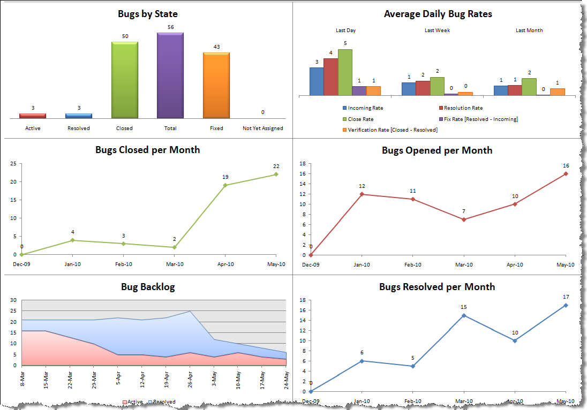

Figure - Defect Report Example using Team Foundation Server (TFS)

* A Final Test Summary Report will be issued by the Test Manager. It will certify the extent to which testing has been completed, and provide an assessment of the product readiness for Program End-to-End Testing <add more details>

## Test Environment Control

### Summary

<explain who will be managing and procedures>.

### Release versioning

<explain how versioning works>

|  |  |
| --- | --- |
| **Version #** | **Description of version** |
| 0.0.1 | <explain> |
| 0.0.2 | <explain> |
| 1.0.0 | <explain> |
| 1.0.1 | <explain> |

**Table**  **- Version numbering example**

## Testing Resources

### <person 1> - Project Manager

Responsible to:

* <enter details>

Responsible for:

* <enter details>

### <person 2> - Business Analyst

Responsible to:

## Testing Tool

<describe what testing tools to be used and for what>

# Appendix

<add screenshots, templates, form that relates to testing or test software will be used>

1.
2. In Requirement Driven Testing it is recommended that [each defect must be linked to at least one requirement and test case](http://www.requirementdriventesting.com/software-test-methodology-rdtrule4/).